MyActivityBot
Motion Control Your Parallax ActivityBot

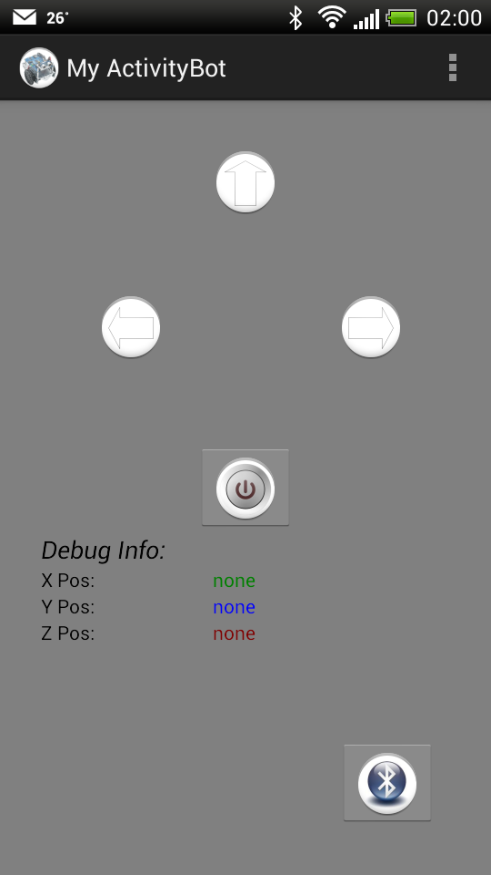

“Hope you'll have more fun with your bot!”

Kenichi K.
Designer & Developer

Getting Started

What you'll need:

- Parallax ActivityBot
- *Bluetooth module (mount on ActivityBot)
- Android smartphone (Android OS 2.2 & above)

*Please ensure your Bluetooth module has UART (Rx/Tx) connectivity to your Propeller on your ActivityBot. In this example, I'm using Parallax's Easy Bluetooth module, which as of this writing, is a discontinued product.

Setup

ActivityBot
- Please assemble & calibrate your ActivityBot according to Parallax's manual & documentation.
- Mount your Bluetooth module onto the mini breadboard on the Activity board. In my example & code, Bluetooth's Rx connects to P10 via a 100ohm resistor in series & Tx connects to P11 via a 1Kohm as current-limiting resistor. Then connect the Vdd & Vss accordingly.

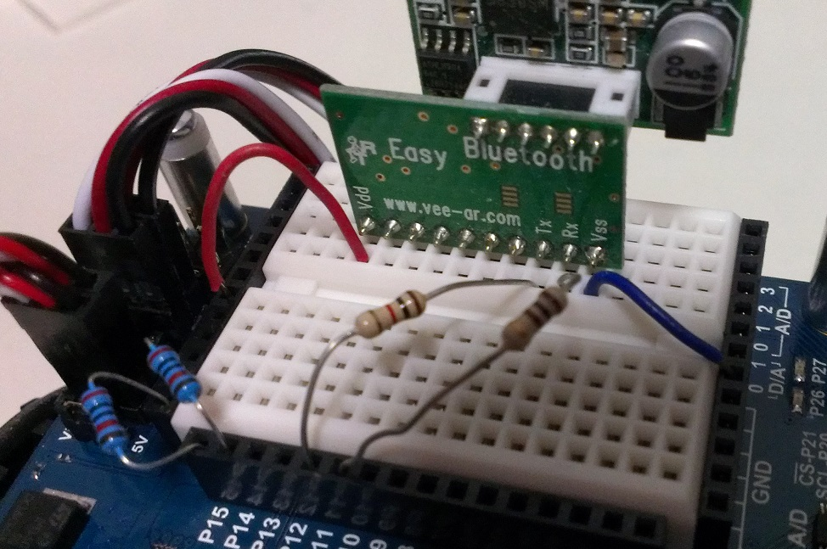

- Launch Parallax SimpleIDE & load the MyActivityBot C code into your bot's EEPROM.
- Switch OFF your ActivityBot.

Launch & Play

Android Smart Phone
- Launch Google Play app & search for “MyActivityBot”.
- Install the app.
- Once installed, launch the app.
- If your Bluetooth is not currently turned on, it will ask you to switch ON.
- Press the Bluetooth icon & select your paired Bluetooth module. If not paired, press “Scan for devices” to search & add to your phone.



- Once done, switch on your ActivityBot (switch# 2) & turn your phone pointing it downwards to ensure zero acceleration.

- Then, press the Power Switch icon to start the communication with your ActivityBot.



X-axis controls Left & Right

Y-axis controls Acceleration
Pointing Down => Slow/Stop
Pointing Up => Fast

C code (PropGCC)

MyActivityBot.c

/*
Project: Controlling MyActivityBot via Bluetooth/
Author: Kenichi K. (a.k.a. MacTuxLin)

*/
#include "simpletools.h" // Include simple tools
#include "KenichiActivityBot.h"
#include "fdserial.h"
#include "abdrive.h"

int *portNumPt; // Handler for UART with Bluetooth
volatile unsigned int statusFlag = false; // User's switch
uint stack[(160 + (50 * 4)) / 4];

int main(){ // Main function

// Init
int cogLED;
int rxData;
int cmdStream[BUFFLENGTH];

// Setup
//hwSetup();
//hwSetup(rxPort, txPort, modeValue, baudRate);
fdserial *portNumPt = fdserial_open(rxPort, txPort, modeValue, baudRate);
pause(500);

// Launch Cog# 1
cogLED = cogstart(&connectionLED, NULL, stack, sizeof(stack));

while(1){

// Get Cmd
//rxData = fdserial_rxCheck(portNumPt);
rxData = fdserial_rxChar(portNumPt);
rxData ^= CHECKSUM;

//print("rxData : %d", rxData);

// Checking for Start/Stop Byte
switch(rxData){
case STARTBYTE:
statusFlag = true;
drive_trimSet(0, 0, 0);
break;
case STOPBYTE:
statusFlag = false;
drive_speed(0, 0);
drive_trimSet(0, 0, 0);
break;
}

// Processing Cmd
if(statusFlag){
// Get set stream of data
while(fdserial_rxCheck(portNumPt) != CHECKSUM){}
//dummy = fdserial_rxChar(portNumPt);
for(int i=0; i<3; i++){
cmdStream[i] = fdserial_rxChar(portNumPt);
}

//--- Move ActivityBot ---

// Debugging: Testing
print("\nL: %d | ", cmdStream[0]); // Left Speed
print("R: %d | ", cmdStream[1]); // Right Speed
print("F: %d ", cmdStream[2]); // Speed Multiplier
// Debugging: Testing

drive_speed(cmdStream[0] * cmdStream[2], cmdStream[1] * cmdStream[2]);
//pause(50);
}else{
drive_speed(0, 0);
}

}
}

void hwSetup(int rx, int tx, int mode, int baud){
//void hwSetup();
fdserial *portNumPt = fdserial_open(rx, tx, mode, baud);
//fdserial *portNumPt = fdserial_open(rxPort, txPort, modeValue, baudRate);
pause(500);
}

void connectionLED(void *par){

int delayDuration = 0;

while(1){
if(statusFlag==0){ //<-- Not consistent, not sure why???
//delayDuration = notConnected;
delayDuration = 1000;
}else{
//delayDuration = connected;
delayDuration = 150;
}

high(signalLED);
pause(delayDuration);
low(signalLED);
pause(delayDuration);
}
}

MyActivityBot.h

// H/W declaration
// Drives
#define leftServo 12
#define rightServo 13
#define leftEncoder 14
#define rightEncoder 15

// Feedback
#define signalLED 26

// Bluetooth/UART
#define rxPort 11
#define txPort 10
#define modeValue 0
#define baudRate 9600

// Delay
#define signalPause 100
#define notConnected 1000
#define connected 150

// Logics
#define true 1
#define false 0

// Cons
#define uint unsigned int

// Comm Protocol
#define STARTBYTE 0xA1
#define STOPBYTE 0xAF
#define CMDSTREAM 0xAA
#define CHECKSUM 0x7F
#define BUFFLENGTH 6

// Function Prototypes
//void hwSetup();
void hwSetup(int rx, int tx, int mode, int baud);
void connectionLED(void *par); // Cog 1

